# Question 4: Surveillance Ethics and Privacy Risks

**With the use of AI for real-time crowd movement analysis, facial recognition, and sentiment tracking, what are the primary ethical and data privacy risks festival organizers must address to use these tools for security and safety responsibly?**

# When Security Becomes Intrusion

In December 2024, Spain fined Club Atlético Osasuna €200,000 and ordered deletion of all biometric data. That same month, Denmark approved facial recognition at FC Copenhagen’s stadium for football matches—but denied the identical system for concerts at the same venue. The principle: biometric surveillance isn’t categorically legal or illegal. It depends on proportionality.

Meanwhile, over 40 festivals—Bonnaroo, Lollapaloola, Electric Forest—pledged never to use facial recognition after sustained artist campaigns. Red Rocks abandoned Amazon palm-scanning after 300+ artists protested. When surveillance feels invasive, festivals face artist boycotts, attendee backlash, and seven-figure fines.

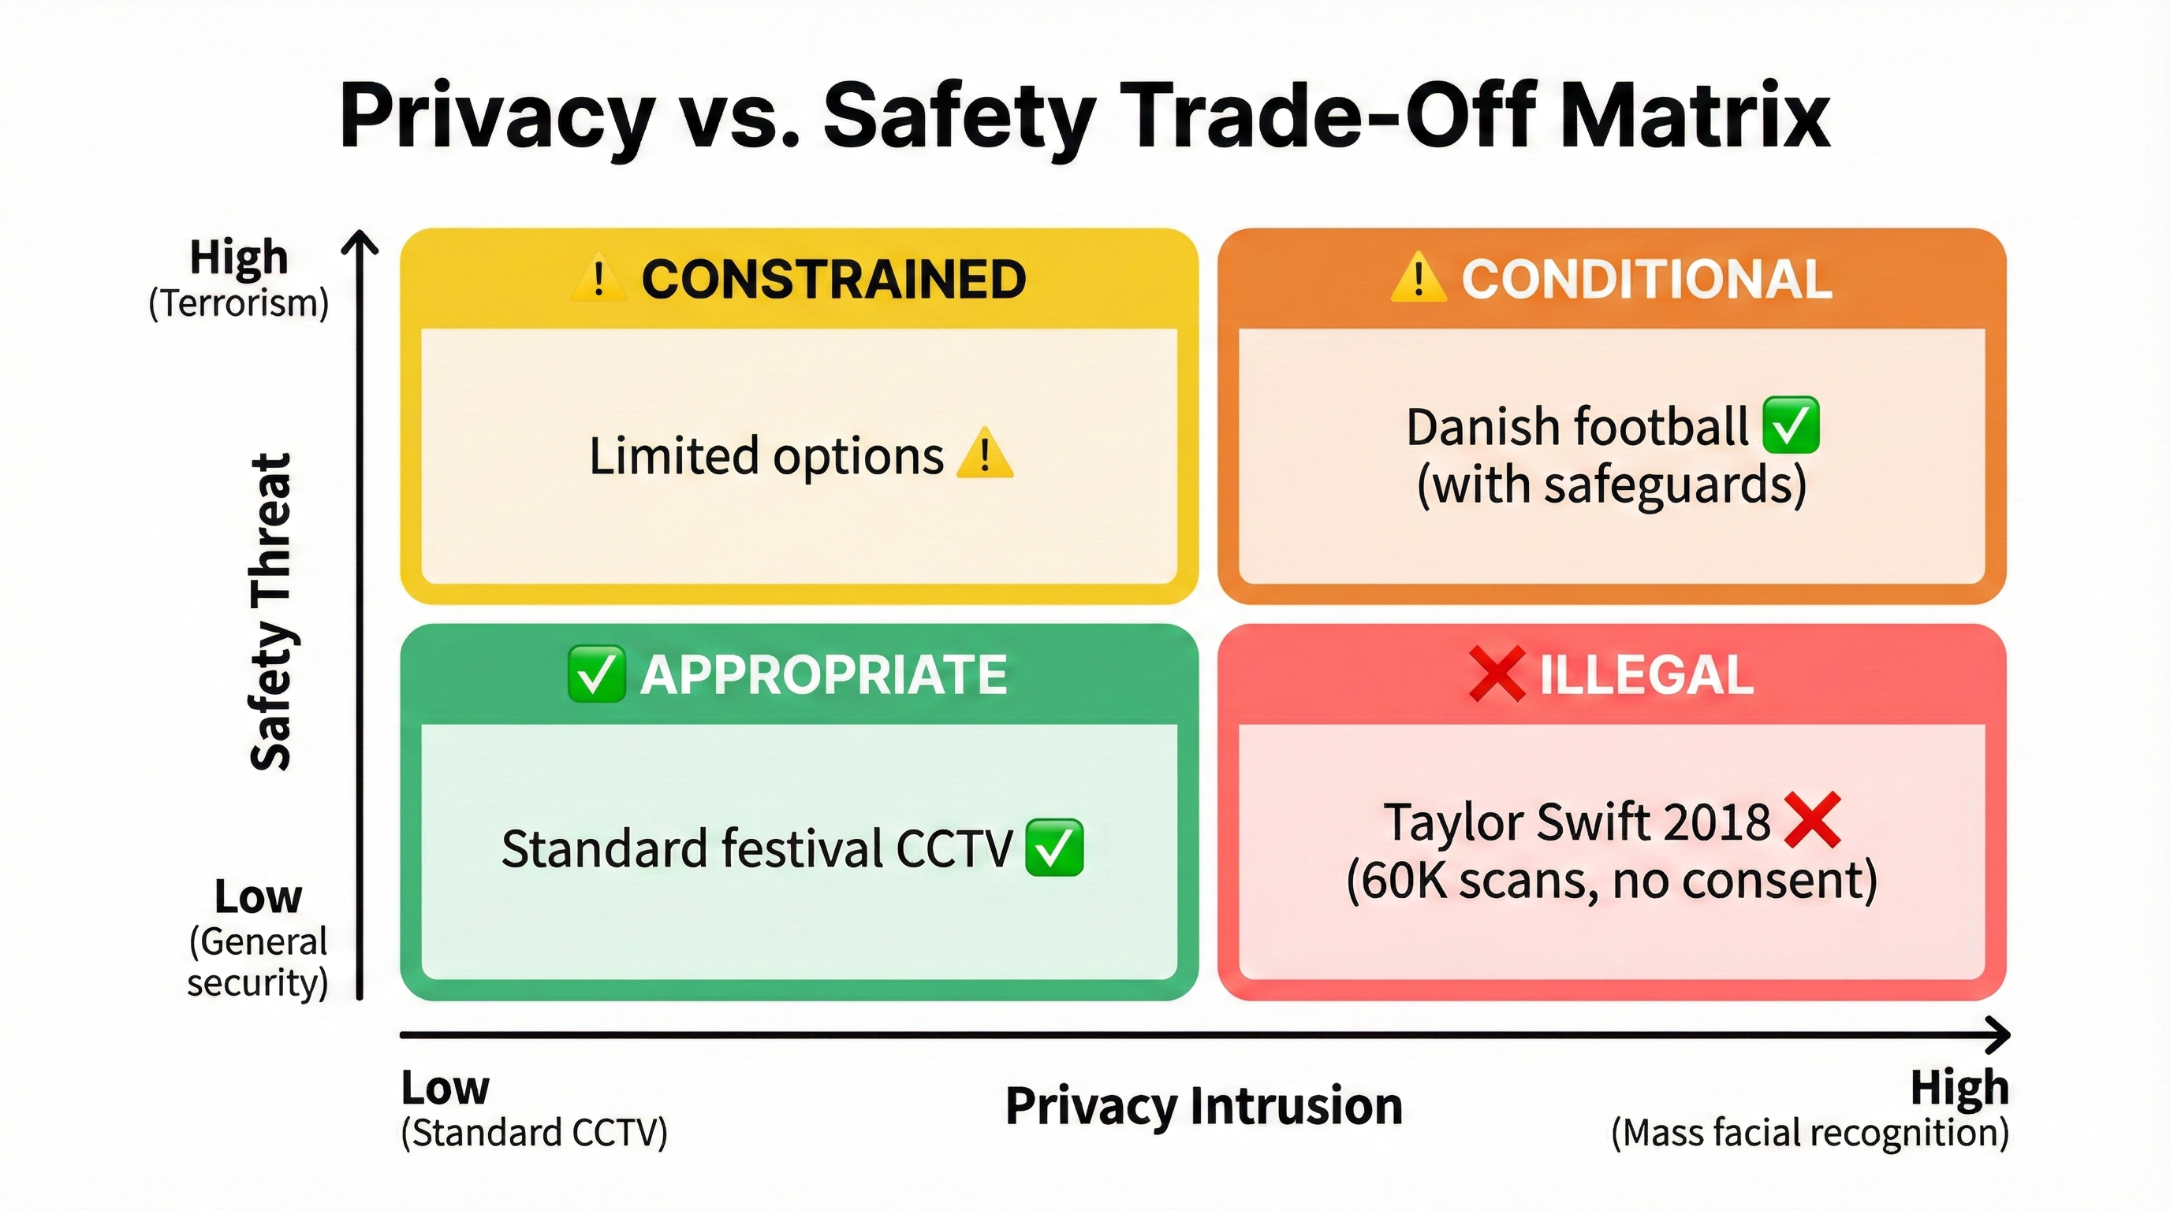 *Figure 4.1: The Privacy vs. Safety Trade-Off Matrix illustrates when biometric surveillance is appropriate (high threat, low intrusion), conditional (moderate scenarios requiring case-by-case evaluation), constrained (high intrusion requiring strict safeguards), or illegal (low threat, high intrusion). The framework guides proportionality assessments required under GDPR Article 9 and the Danish “Concerts ≠ Football” principle.*

## Risk 1: Covert Surveillance Without Consent

**Taylor Swift Rose Bowl (2018)**

May 2018: sixty thousand fans walked past kiosks showing rehearsal footage at the Rose Bowl. What they didn’t know was that each screen was scanning their faces, cross-referencing against a database of Swift’s known stalkers. There was no signage explaining what was happening, no opt-in process, and no way to decline.

When Rolling Stone broke the story months later, the ACLU condemned it as “unacceptable surveillance.” Regulators still cite the incident in guidance on covert biometric processing. Had this occurred in the EU, Swift’s team would face GDPR violations carrying penalties up to €20 million or 4% of global turnover. Under California’s CCPA, biometric data qualifies as “sensitive personal information” that requires explicit notice and opt-out rights.

**Madison Square Garden (2022-2024)**

MSG Entertainment deployed facial recognition to identify attorneys from law firms suing the company—then ejected them mid-event, even from unrelated entertainment venues. An attorney celebrating her daughter’s birthday at Radio City Music Hall was removed from the venue. A lawyer chaperoning a Girl Scout troop was escorted out mid-show.

The backlash was swift: over 100 artists announced boycotts by July 2023, and the New York Legislature banned the practice in June 2024. The lesson here is clear—legal doesn’t mean socially acceptable.

## Risk 2: Regulatory Violations and €200,000 Fines

**Mobile World Congress 2021**

The GSMA deployed facial recognition for conference entry at Mobile World Congress in Barcelona. The system was optional—43% of attendees opted in while 57% used manual ID verification instead. Spain’s data protection authority fined them €200,000 anyway.

The violation wasn’t about forced enrollment. Article 35 of GDPR requires organizations to complete a Data Protection Impact Assessment (DPIA) before deploying biometric systems. The GSMA submitted one, but Spanish regulators called it “merely nominal” because it failed to examine necessity, proportionality, risks, or safeguards. The lesson: opt-in consent doesn’t equal GDPR compliance. Rigorous DPIAs cost €20,000-€80,000 in consulting fees, but they mitigate €200,000+ fines.

**Club Atlético Osasuna (December 2024)**

Spain fined the Spanish football club Osasuna €200,000, ordered deletion of all biometric data, and prohibited any further facial recognition use. The proportionality failure was stark: regulators determined that “marginal benefits did not justify the processing” when QR codes already enabled efficient access control. Convenience alone isn’t sufficient justification under GDPR.

That same year, La Liga received a €1,000,000 fine for biometric identification without proper DPIA documentation. The pattern is clear: European regulators take biometric violations seriously, and optional systems receive no special treatment.

## Risk 3: Algorithmic Bias and Discriminatory Harm

**NIST Test (2019)**

The National Institute of Standards and Technology evaluated 189 commercial facial recognition algorithms in 2019. The findings were damning: false positive rates run 10-100 times higher for Asian and African American faces compared to Caucasian faces. Women are misidentified more frequently than men across most systems tested.

**Seven Wrongful Arrests**

These aren’t theoretical problems. Robert Williams was detained for 30 hours in Detroit for shoplifting he didn’t commit—the victim was shown his photo based on facial recognition and made a misidentification. Porcha Woodruff was eight months pregnant when Detroit police arrested her for carjacking based on faulty facial recognition. Randal Reid was arrested in Georgia for crimes committed in Louisiana, detained for six days despite being in another state at the time of the crimes.

The pattern across these seven documented wrongful arrests is disturbing: six of the seven victims are Black individuals. The technology’s bias isn’t abstract—it creates real harm.

For festivals, the math is sobering. A 1% false positive rate at a 50,000-person event means 500 innocent attendees flagged for ejection or detention. That creates civil liability, reputational damage, and violations of Illinois’ Biometric Information Privacy Act (BIPA), which carries statutory damages of $1,000-5,000 per person. Unlike a password you can change, you can’t reset your face. When Biostar 2 exposed 27.8 million biometric records in 2019, affected individuals had no recourse to prevent future identity theft. Under Illinois BIPA, a data breach affecting 10,000 attendees could generate $10-50 million in statutory damages.

## Danish DPA Test: Concerts ≠ Football

In December 2024, FC Copenhagen proposed deploying facial recognition at Parken Stadium for both football matches and concerts. Denmark’s data protection authority approved it for football but denied it for concerts at the identical venue.

The football rationale was compelling: documented hooliganism incidents, banned individuals on police suspension lists, previous violent confrontations, and substantial public interest in preventing violence. The concert rationale fell apart under scrutiny: no documented security problems, no history of violence, no banned individual lists. QR codes already provided adequate access control without biometric surveillance.

The principle here is fundamental: biometric surveillance must be proportionate to documented threats, not merely convenient. Festivals can’t claim “general security” as justification—they must demonstrate specific, substantial risks that less intrusive measures can’t adequately address.

Four questions test proportionality in practice. First: Is there documented incident history? If your justification is “we just want faster entry,” proportionality likely fails. Second: Are less intrusive alternatives available? RFID wristbands, mobile tickets, and trained security personnel exist—if they work adequately, deploying biometric systems fails the proportionality test. Third: What’s the false positive rate? At 50,000 attendees with a 1% error rate, that means 500 wrongful ejections—an unacceptable outcome. Fourth: Can you demonstrate GDPR Article 35 compliance with rigorous DPIA documentation? The assessments cost €20,000-€80,000, but both GSMA and Osasuna paid €200,000 fines for inadequate compliance.

## Responsible Surveillance: The Paris 2024 Model

Paris deployed AI-powered crowd monitoring across 35 Olympics venues using Cityvision software, explicitly excluding facial recognition technology. The system’s capabilities included crowd surge detection, abandoned object identification, weapon detection, fire and smoke detection, and anonymized density analysis. Critically, the system knows “100 people in this zone” without knowing who those people are—it never identifies “John Smith is in this zone.”

Why it works comes down to four principles: the surveillance was proportionate to mega-event security needs, privacy-by-design architecture explicitly excluded biometric identification, transparent governance with French data protection authority (CNIL) oversight provided accountability, and specific legal authorization with a sunset date of March 31, 2025 prevented perpetual surveillance creep.

The takeaway for festival organizers is straightforward: you can implement effective AI crowd density monitoring without biometric identification. Paris 2024 demonstrates that it’s technically feasible and legally compliant.

## Why Sports Succeeded Where Festivals Failed

Cleveland Browns deployed Wicket facial recognition at their stadium, achieving over 50% enrollment among season ticket holders and reducing entry time to two seconds per person. The deployment succeeded for two reasons: repeat attendance across eight+ home games justifies the one-time enrollment friction, and NFL stadiums have well-documented violence histories that support proportionality arguments.

Over 40 festivals rejected identical technology despite similar throughput benefits. Musicians Tom Morello and Amanda Palmer led opposition campaigns that gathered 300+ artist signatures. Live Nation and AEG, the two largest festival promoters globally, functionally pledged not to deploy facial recognition at their events.

The difference isn’t technical—it’s contextual. One-time festival attendance offers minimal return on investment for enrollment friction, most festivals lack documented violence that would support proportionality requirements, and festival culture fundamentally values spontaneity and serendipity over optimized throughput.

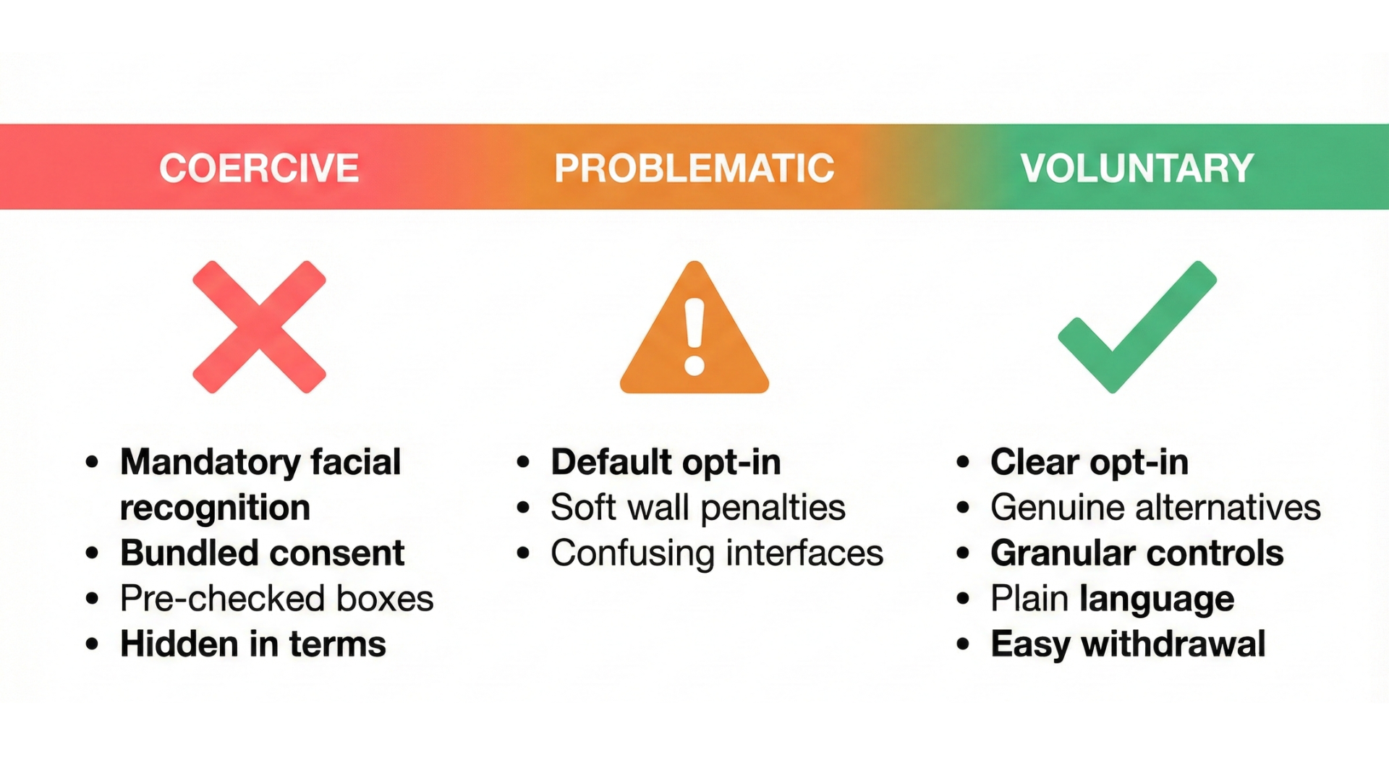 *Figure 4.2: The Consent Architecture Spectrum maps eight consent patterns from coercive (left, illegal under GDPR) to voluntary (right, compliant). Forced enrollment and access barriers fail proportionality requirements, while default opt-out and convenience incentives raise power imbalance concerns. Only equal alternatives with symmetric choice architecture satisfy GDPR Article 9’s “explicit consent” standard for biometric data processing.*

## Regulatory Landscape

**GDPR (EU/UK)**

Under Article 9 of GDPR, biometric data qualifies as “special category” data requiring explicit consent or demonstration of substantial public interest. For private festival organizers, explicit consent means providing genuine alternatives that are equally accessible, making withdrawal as easy as granting consent, and ensuring no power imbalance coerces participation.

Article 35 mandates completing Data Protection Impact Assessments before deployment. Violations trigger fines starting at €200,000 (GSMA and Osasuna both paid this amount), while unlawful processing carries maximum penalties of €20 million or 4% of global turnover, whichever is higher.

**BIPA (Illinois)**

Illinois enacted the strictest biometric privacy law in the United States. The Biometric Information Privacy Act requires written consent before collection, mandates disclosure of purpose and retention schedule, provides a private right of action allowing individuals to sue directly, and establishes statutory damages of $1,000-5,000 per violation.

The enforcement record speaks for itself: Meta settled a BIPA class action for $1.375 billion in 2024, while Google settled for $100 million in 2023. This matters for festivals because Lollapaloola operates in Chicago—any biometric deployment without strict BIPA compliance creates immediate class action risk.

**EU AI Act (Effective February 2, 2025)**

The AI Act bans real-time biometric identification in publicly accessible spaces for private entities, with narrow law enforcement exceptions that require judicial authorization. Post-event biometric identification and AI systems affecting access to services qualify as “high-risk” applications requiring conformity assessment before deployment.

Prohibited uses carry fines up to €35 million or 7% of global turnover, whichever is higher. For festival organizers, the practical implications are clear: real-time facial recognition at entry gates is banned outright, while post-event analysis of recorded footage is high-risk and requires extensive compliance documentation.

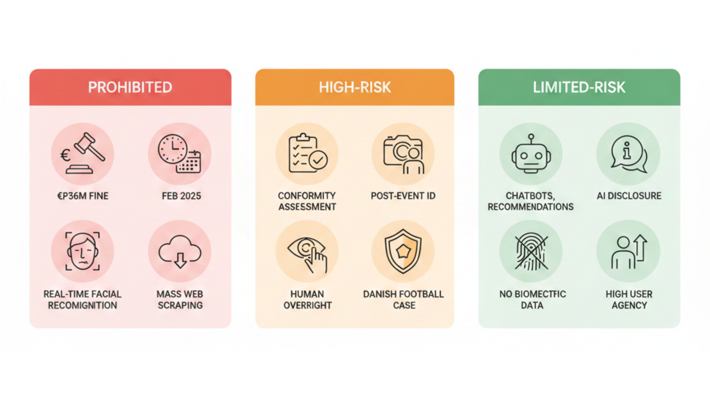 *Figure 4.3: The EU AI Act establishes a three-tier risk framework effective February 2, 2025. Prohibited applications (red) include real-time biometric identification by private entities, carrying fines up to €35M or 7% of global turnover. High-risk applications (yellow) require conformity assessment and include post-event biometric analysis. Limited-risk applications (green) face transparency obligations only. For festivals, this means entry-gate facial recognition is banned outright, while post-event analysis requires extensive compliance documentation.*

## If You Must Deploy Surveillance

Before any deployment, you’ll need to complete a rigorous DPIA, which typically costs €20,000-€80,000 in consulting fees. Consult your Data Protection Officer early in the process. Verify that you have a valid legal basis under GDPR Article 9(2) or BIPA requirements. Check whether your planned use falls under EU AI Act prohibitions. Most importantly, assess proportionality using the Danish framework described earlier.

On the technical side, test your chosen system for demographic bias using NIST-style evaluation protocols. Establish both false positive and false negative rates with statistical confidence intervals. Implement restricted capture zones that prevent passive scanning of people who haven’t opted in. Build robust fallback systems for those who decline participation. Encrypt biometric templates using current best practices, and never store raw biometric images.

For consent architecture, provide genuine alternative entry methods that are equally accessible in practice, not just in theory. Design choice symmetry—opting out should be exactly as easy as opting in, with no hidden friction. Use progressive disclosure that presents essential information upfront before asking for decisions. Avoid dark patterns like pre-checked consent boxes, hidden opt-out processes, or automatic resets that require repeated consent withdrawal. Enable simple withdrawal mechanisms with immediate data deletion.

Governance requirements include limiting retention periods with automatic deletion after the event or season ends. Restrict access to security teams exclusively, with comprehensive audit trails of all data access. Prohibit function creep by ensuring collected data can’t be repurposed without obtaining new explicit consent. Plan detailed breach response procedures that comply with GDPR’s 72-hour notification requirement. For large-scale deployments, issue annual transparency reports documenting system usage and safeguards.

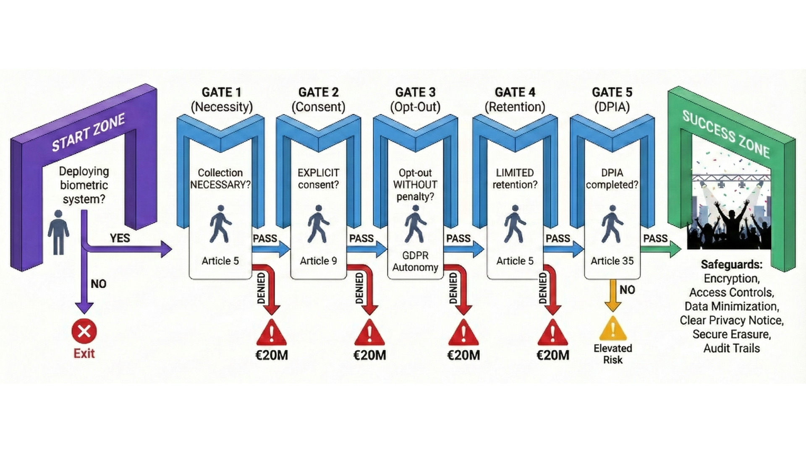 *Figure 4.4: The GDPR Biometric Compliance Decision Tree guides festival organizers through five checkpoints: biometric data classification (Article 9 special category), legal basis evaluation (explicit consent or substantial public interest), DPIA completion requirements (Article 35 mandate), proportionality assessment (Danish framework), and ongoing obligations (retention limits, access controls, breach response). All five must pass for lawful deployment—GSMA and Osasuna both paid €200,000 fines for inadequate DPIA despite meeting other requirements.*

## The Bottom Line

Every festival organization faces the choice that Spanish regulators priced at €200,000: deploy surveillance systems responsibly with documented proportionality, or face the consequences of non-compliance.

Consider what we’ve seen: over 40 festivals chose outright rejection over reputational risk, Denmark’s data protection authority denied concerts while approving football at the identical venue, Paris 2024 demonstrated that effective crowd monitoring works without facial identification, €200,000+ fines have become routine enforcement, and artist boycotts numbering 100+ artists create existential threats to festival viability.

The responsible path exists and doesn’t require abandoning safety technology. AI crowd density monitoring using fluid dynamics and anonymous sensors, RFID wristbands like Tomorrowland’s proven system, and well-trained security personnel all provide effective alternatives. Biometric surveillance isn’t impossible—it’s just rarely proportionate for festival contexts. Without documented security incidents comparable to football hooliganism, regulators consistently apply Denmark’s standard: Concerts ≠ Football.

For students entering the festival industry and professionals already working in it: you’ll encounter pressure to deploy surveillance AI. The question isn’t whether the technology works—it does. The question is whether you’ll have the frameworks to say “no” when deployment is inappropriate and the courage to advocate for privacy-respecting alternatives. €200,000 fines, artist boycotts, and regulatory denials send a clear message that convenience alone isn’t sufficient justification for biometric surveillance. Festivals that learn this lesson avoid consequences. Those that don’t learn it expensively.

**Sources:**

* [ACLU: The problem with using face recognition on fans at a Taylor Swift concert](https://www.aclu.org/news/privacy-technology/problem-using-face-recognition-fans-taylor-swift)
* [ACLU: Williams v. City of Detroit - Face recognition false arrest](https://www.aclu.org/cases/williams-v-city-of-detroit-face-recognition-false-arrest)
* [AEPD (Spain): La Liga €1,000,000 fine for biometric processing without DPIA - Decision EXP202315637](https://gdprhub.eu/index.php?title=AEPD_(Spain)_-_EXP202315637)
* [Big Brother Watch: Stop facial recognition campaign report](https://bigbrotherwatch.org.uk/campaigns/stop-facial-recognition/report/)
* [Büchi, M., Festic, N., & Latzer, M. (2022). The chilling effects of digital dataveillance. Big Data & Society](https://journals.sagepub.com/doi/10.1177/20539517211065368)
* [CBS News: Madison Square Garden faces scrutiny over facial recognition technology](https://www.cbsnews.com/news/madison-square-garden-face-recognition-illegal-new-york-attorney-general-letitia-james/)
* [Center for Democracy and Technology: EU AI Act brief - Privacy and surveillance](https://cdt.org/insights/eu-ai-act-brief-pt-2-privacy-surveillance/)
* [Danish Data Protection Authority: Decision 2024-51-0012 on FC Copenhagen facial recognition](https://gdprhub.eu/index.php?title=Datatilsynet_(Denmark)_-_2024-51-0012)
* [ECNL: Hungary’s new biometric surveillance laws violate AI Act](https://ecnl.org/news/hungarys-new-biometric-surveillance-laws-violate-ai-act)
* [Electronic Frontier Foundation: About Face - EFF’s work on face recognition](https://www.eff.org/aboutface)
* [European Parliament: EU AI Act - First regulation on artificial intelligence](https://www.europarl.europa.eu/topics/en/article/20230601STO93804/eu-ai-act-first-regulation-on-artificial-intelligence)
* [Fight for the Future: Ban facial recognition from festivals](https://festivals.banfacialrecognition.com/)
* [GDPR Article 9: Processing of special categories of personal data](https://gdpr-info.eu/art-9-gdpr/)
* [National Academies of Sciences: Facial recognition technology - Current capabilities, future prospects, and governance](https://nap.nationalacademies.org/read/27397/chapter/5)
* [National Institute of Standards and Technology (2019): Face Recognition Vendor Test Part 3 - Demographic Effects](https://nvlpubs.nist.gov/nistpubs/ir/2019/NIST.IR.8280.pdf)
* [New York Attorney General: Attorney General James seeks information from Madison Square Garden regarding use of facial recognition technology](https://ag.ny.gov/press-release/2023/attorney-general-james-seeks-information-madison-square-garden-regarding-use)
* [New York State Bar Association: Privacy vs. security - The legal implications of using facial recognition technology at entertainment venues](https://nysba.org/privacy-vs-security-the-legal-implications-of-using-facial-recognition-technology-at-entertainment-venues/)
* [NPR: Facial recognition technology at MSG has sparked new concerns](https://www.npr.org/2023/01/21/1150289272/facial-recognition-technology-madison-square-garden-law-new-york)
* [Pew Research Center (2022): Public more likely to see facial recognition use by police as good rather than bad for society](https://www.pewresearch.org/internet/2022/03/17/public-more-likely-to-see-facial-recognition-use-by-police-as-good-rather-than-bad-for-society/)
* [Privacy International: Blank space - Why Taylor Swift doing facial recognition is a bad idea](https://privacyinternational.org/news-analysis/2547/blank-space-why-taylor-swift-doing-facial-recognition-bad-idea)
* [Rolling Stone: Taylor Swift used facial recognition at concert to identify stalkers](https://www.rollingstone.com/music/music-news/taylor-swift-facial-recognition-concerts-768741/)
* [Stadium Tech Report: Wicket’s facial authentication technology a ticket to success for Cleveland Browns](https://stadiumtechreport.com/feature/wickets-facial-authentication-technology-a-ticket-to-success-for-cleveland-browns/)
* [UNESCO: Recommendation on the Ethics of Artificial Intelligence](https://www.unesco.org/en/articles/recommendation-ethics-artificial-intelligence)